7COM1079-0901-2025 - Team Research and Development Project

Final report title: Comparative Analysis of Domestic Violence Rates Between North India and South India States: A Statistical Analysis (2001-2014).

Group ID: B 107

Dataset number: ds206

Prepared by: 1. Faizan Shafi Seroo.
Student ID Number: 23088135

2. Hanumath Srinivasa Dixit Ghadiyaram.
Student ID Number: 23092742

3. Bharat Kumar Kondrapu.
Student ID Number: 23088621

4. Pallavi Urrakula.
Student ID Number: 23090215

University of Hertfordshire
Hatfield, 2025
Table of Contents

- Introduction page no.

  - Problem statement and research motivation………………………………… 3
  - The data set………………………………………………………………….. 3
  - Research question…………………………………………………………… 3
  - Null hypothesis and alternative hypothesis (H0/H1)……………………….. 3

- Background research

  - Research papers (at least 3 relevant to your topic / DS)…………………….. 4
  - Why RQ is of interest (research gap and future directions according to the literature)…………………………………………………………………… 4

- Visualisation

  - Appropriate plot for the RQ output of an R script (NOT a screenshot) and required supplementary graph/table………………………………………... 4
  - Additional information relating to understanding the data (optional)……… 5
  - Useful information for the data understanding……………………………... 6

- Analysis
  - Statistical test used to test the hypotheses and output……………………… 6
  - The null hypothesis is rejected /not rejected (select one) based on the p-value………………………………………………………………………… 6

- Evaluation – group’s experience at 7COM1079
  - What went well……………………………………………………………… 6
  - Points for improvement……………………………………………………… 6
  - Group’s time management…………………………………………………... 7
  - Project’s overall judgement………………………………………………….. 7
  - Comment on GitHub log output……………………………………………… 7

- Conclusions
  - Results explained……………………………………………………………. 7
  - Interpretation of the results………………………………………………….. 7
  - Reasons and/or implications for future work, limitations …………………... 8

- Reference list………………………………………………………………………… 8
Harvard (author, date) format.
- Appendices …………………………………………………………………………. 9
- R code used for analysis and visualisation.
- GitHub log output.

1. Introduction

  - Problem statement and research motivation (100 words)

The Domestic Violence against women, particularly ‘Cruelty by husband or his relatives,’ is still a major problem in India. This issue has different levels depending on the region. It is important to understand the differences between North and South India, as these areas have different traditions, awareness of laws, and ways of handling gender-based violence. This study checks if there is a real, measurable difference in reported domestic violence rates between North and South India. It uses detailed data from 2001 to 2014. Finding these patterns can help guide specific aid and allocate resources more effectively to deal with this social issue (Hackett, 2011)

  - The data set (75 words)

We have used the National Crime Records Bureau’s “Crime against women in India (2001-2014)” dataset for our analysis. This dataset includes statistics for various crime types at the state or UT level. The study looks specifically on “Cruelty by Husband or his relatives.” After cleaning the data to remove the overall total rows, states were grouped into North India (Delhi, Uttar Pradesh, Rajasthan, Punjab, Haryana) and South India (Kerala, Tamil Nadu, Karnataka, Andhra Pradesh) for comparison analysis

  - Research question. (50 words)

Our Research question is stated as “Is there a Statistically significant difference in mean rates of ‘Cruelty by husband or his relatives’ between North Indian States (Delhi, Uttar Pradesh, Rajasthan, Punjab, Haryana) and South Indian States (Kerala, Tamil Nadu, Karnataka, Andra Pradesh) during 2001 to 2014?”

  - Null hypothesis and alternative hypothesis (H0/H1) (100 words)

Null Hypothesis(H0): There is no significant difference in mean cruelty rates between North Indian States and South Indian States. ($µ North= µ South$).

Alternative Hypothesis(H1): There is a significant difference in mean cruelty rates between north Indian states and south Indian states.
($µ North≠ µ South$).

We will use Mann-Whitney U test to check our Hypothesis. This is an appropriate way for comparing two independent groups with non-normal distributions. A significant level of α = 0.05 will determine the statistical significance.

- Background research
  - Research papers (at least 3 relevant to your topic / DS) (200 words)

Hacket (2011) looked at domestic violence crimes across all of India with statistics. The study found big differences between regions in how many cases get reported. Things like education, money, and the police access effects both how much violence happens and how much get reported.

Aggarwal and others (2023) used graphs and predictions to study crimes against women in Indian states. Their research showed ways to find high risk areas and see the trends over time. This gives a good way for making policies based on evidence.

Chauhan and Baraik (2016) did space and time analysis of crime against women from 2001 and 2012. They made maps showing where crimes happens most. Their work show why long term data is important for understanding how violence against women changes in different states over all years.

  - Why RQ is of interest (research gap and future directions according to the literature) (100 words)

Our research question is interesting because not many studies directly compare North India and South India with different data over 14 years. Most of the research looks at whole country or just one region. We did proper statistical testing to see if there was a real difference. Finding these patterns could help different communities make policies for each area. Future studies could add more information like income or education, or talk to women directly to understand why these things happen.

- Visualisation
  - Appropriate graphs for the RQ (50 words)

We used a Boxplot which compares cruelty case distribution between North and South India, it shows us that North India’s has much higher median (14 cases) against the South India (5 cases). The north also has more spread in the data, which means number cases changes from place to place. These differences support our research question about comparing the means of two regions.

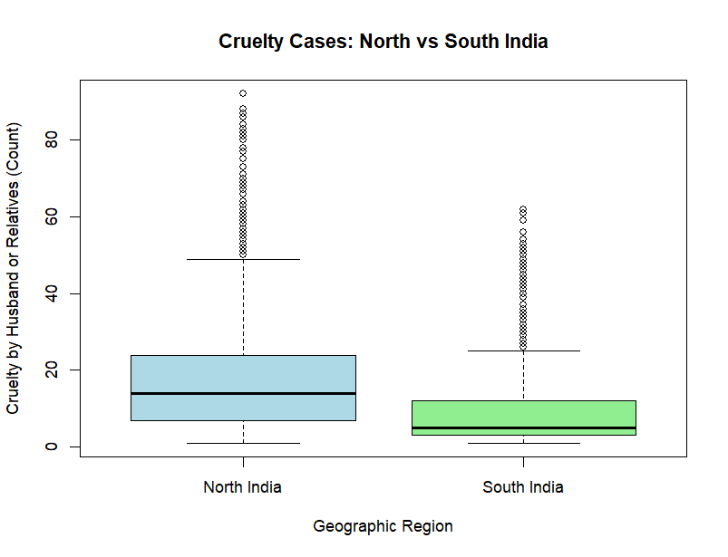
Figure 1. Comparison of Domestic Violence Cases Between North and South Indian States (2001-2014)
The box plot shows distribution of ‘cruelty by husband or relatives’ cases in north and south india.

  - Additional information relating to understanding the data (optional) (50 words)

The Histograms shows frequency distribution for each region. Both regions have right skewed patterns, which means North India contains more high value outliers. South India’s cases mostly fall in the lower range (1-12 cases), while north India spreads across broader range (1-92 cases), showing clear distributional differences.

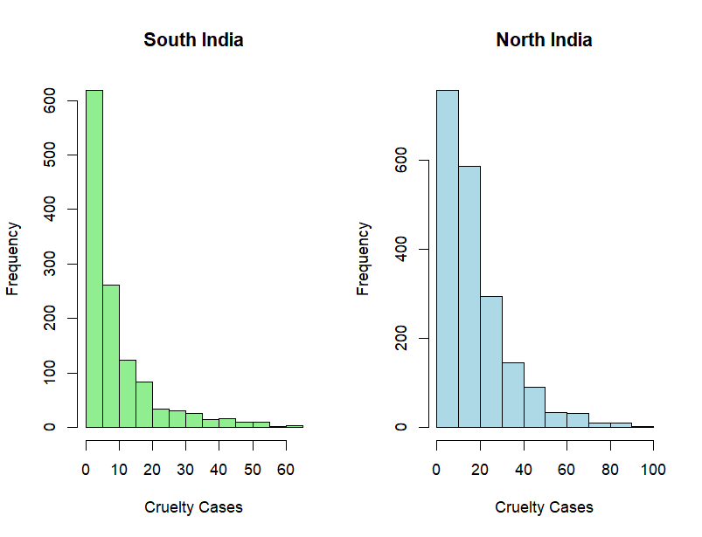
Figure 2. Frequency Distribution of Domestic violence cases by Region.
Histograms showing frequency distributions for (A) South India and (B) North India. Both regions display right-skewed distributions, with North India showing more high-value outliers.

  - Useful information for the data understanding (50 words)

The graphs shows that North India has higher average numbers and more spread out data. Both data is not normal shaped, which is why we picked our statistical test. The clear difference in pictures suggest real regional patterns in how domestic violence gets reported.

- Analysis
  - Statistical test used to test the hypotheses and output (75 words)

We used Mann-Whitney test because, the data we have used was not normal shaped. This test compares of two separate groups without needing equal spread. We are comparing two groups, so we need a test for two groups. The result gave a W number of 1,725, 268 with p-value less than 0.001. this was the right test for our question comparing average cruelty rates between north india and south india using data from 2001 to 2014.

  - The null hypothesis is rejected /not rejected based on the p-value (100 words)

The null hypothesis says there is no real difference in cruelty rates between North and South Indian states. We test this to know if the difference we see is real or just random chance. We got p less than 0.001 so we reject the null hypothesis because there is less than 0.1% chance the difference happened by luck. This means there is a real difference in domestic violence rates. North India has higher rates. These results support our other hypothesis which is a meaningful difference in domestic violence between north and south india.

- Evaluation – group’s experience at 7COM1079
  - What went well (75 words)

Working in a team helped us understand the project better, and splitted the tasks fairly. We talked regularly to stay on the same page and used Git to share files. We carefully checked the dataset, fixed issues like TOTAL rows, and did the full analysis in R. Creating graphs, running tests, and explaining the results improved our confidence in using R. Overall, the work went smoothly and putting things together was easy because we used the tempelate from start.

  - Points for improvement (75 words)

At start, we had some tough time regarding understanding the dataset and choosing the right statistical tests. We also spent extra time solving R issues such as reading the CSV file, cleaning the data, and removing unnecessary rows. With more planning and early checks, we could have avoided some delays. Learning more about R packages and documentation would also help us work faster in future projects and also Mann- Whitey test earlier would have saved some time.

  - Group’s time management (50 words)

We tried to keep work in schedule ans splitted tasks early, like cleaning data, making graphs, testing hypotheses, and writing the report. Beginning took longer time learning the dataset and things like, forming the hypothesis and improving the plots. In future work, spending more time reviewing the results could improve our workflow.

  - Project’s overall judgement (50 words)

We met the project goals by answering the research questions and testing the hypotheses. The analysis was suitable, and the result was clearly supported by statistical evidence. Doing the practical work together helped us better understand, how to manage and analyse data effectively.

  - Note any changes to group since original allocation if applicable. Add new or amended GitHub Ids for new members (75 words, write only if applies to your group arrangements)
  - Comment on the GitHub log output (50 words)

We used Github to work together as a team. Each member added their files correctly. The commit history shows our progress from adding the data to finishing the repport. You can see our main steps in Appendix B. It helped us stay organised and share our work properly.

- Conclusions
  - Results explained (75 words)

Our results and analysis that we did found a clear difference between North and South India’s Cruelty cases. North India has more reported cruelty cases, with middle value of 14, than the South India, with middle value of 5. The statistical test gave us a very small p-value, which means that the difference is real and not by chance. And yes, there is a significant difference in domestic violence rates between the two regions based on 2001-2014 data, which satisfies our research question.

  - Interpretation of the results (75 words)

Our results found that North India reports more cruelty cases, that could mean more violence in north or may be due to stronger reporting systems, better awareness, women their report more cases. The increasing trend might also reflect, which changes social attitudes and easier access for a legal support. These regional differences show the importance of tailored policies and intervention strategies.

  - Reasons and/or implications for future work, limitations of your study (50 words)

Our study uses reported crime data, which may not include unreported cases due to cultural or social barriers. Future work could add socio-economic data, qualitative research, talking to women directly, or machine learning models to make better policies for each region.

- Reference list
Harvard (author, date) format.

      - Hackett, M. (2011). Domestic violence against women: Statistical analysis of crime across India.
Journal of Comparative Family Studies, pp.267-288.

      - Aggarwal, S., Aggarwal, and Bansal, M. (2023). Crimes against women and girls in Indian states:
Analysis, visualization, and prediction. International Journal of Innovation and Multidisciplinary
Research, 3(4), p.21.

      - Chauhan, R. and Baraik, V.K. (2016). Mapping crime against women in India: Spatio-temporal analysis,
2001-2012. International Journal of Law and Political Sciences, 10(6), pp.2243-2254.

- Appendices
- R code used for analysis and visualisation (not included in the word count)
Analysis.R code with the appropriate statistics to test the hypotheses.

library(readr)

# Read dataset
df <- read_csv("crimes_against_women_2001-2014 (2).csv")

# Clean column names
names(df)[2] <- "state"
names(df)[3] <- "district"
names(df)[7] <- "cruelty"

# REMOVE TOTAL ROWS (not keep only them!)
df2 <- subset(df, district != "TOTAL" & district != "DELHI UT TOTAL")

# Define regions
north_india_states <- c("DELHI", "UTTAR PRADESH", "RAJASTHAN", "PUNJAB", "HARYANA")
south_india_states <- c("KERALA", "TAMIL NADU", "KARNATAKA", "ANDHRA PRADESH")

# Create region column
df2$region <- ifelse(df2$state %in% north_india_states, "North India",
ifelse(df2$state %in% south_india_states, "South India", NA))

# Keep only North and South India
df2 <- subset(df2, !is.na(region))

# Remove NA values in cruelty
df2 <- subset(df2, !is.na(cruelty))

# Remove zero values (optional)
df2 <- subset(df2, cruelty > 0)

# BOX PLOT (main visualization)
boxplot(cruelty ~ region, data = df2,
xlab = "Geographic Region",
ylab = "Cruelty by Husband or Relatives (Count)",
main = "Cruelty Cases: North vs South India",
col = c("lightblue", "lightgreen"))

# TWO HISTOGRAMS SIDE-BY-SIDE (supplementary)
par(mfrow = c(1, 2)) # Show 2 plots side-by-side

hist(df2$cruelty[df2$region == "South India"],
main = "South India",
xlab = "Cruelty Cases",
col = "lightgreen")

hist(df2$cruelty[df2$region == "North India"],
main = "North India",
xlab = "Cruelty Cases",
col = "lightblue")

# Reset plot layout
par(mfrow = c(1, 1))

# Statistical test - Mann-Whitney U test
test_result <- wilcox.test(cruelty ~ region, data = df2)
print(test_result)

# Summary statistics
cat("\n--- Summary Statistics ---\n")
cat("North India:\n")
print(summary(df2$cruelty[df2$region == "North India"]))
cat("\nSouth India:\n")
print(summary(df2$cruelty[df2$region == "South India"]))

- GitHub log output.

      - Create Final Report
according to our research Our analysis found a clear difference between North and South India. The North had more reported cruelty cases (median 14) than the South (median 5). The statistical test gave a very small p-value, meaning this difference is real and not by chance. This answers our main research question: yes, there is a significant difference in domestic violence
      - Mean difference in cruelty by husband or his relatives rates(2001-2014) between north and south Indian states.

Domestic violence remains a major issue in India, with reported rates varying significantly by region. The research is motivated by the need to understand the quantifiable differences between North and South India, as these regions have distinct traditions and approaches to gender-based violence. Identifying these patterns can help in more effective resource allocation and targeted aid.

      - Add Statistical Analysis Code
Mann- Whitney U test Implementation box plot and histogram generation summary statistics calculation

